1. In this lab, concepts regarding directed graphs were explored. This is important as graph searching algorithms are widely used in the industry. For example, most games which have pathfinding usually use variations of BFS such as A\* and Dijkstra's algorithm.

Task 2:

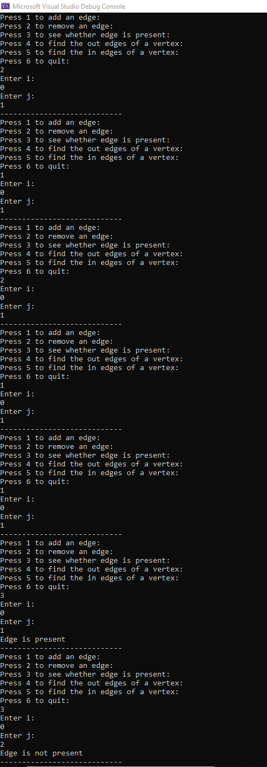

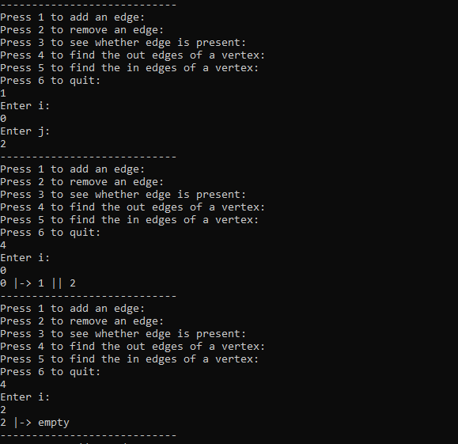

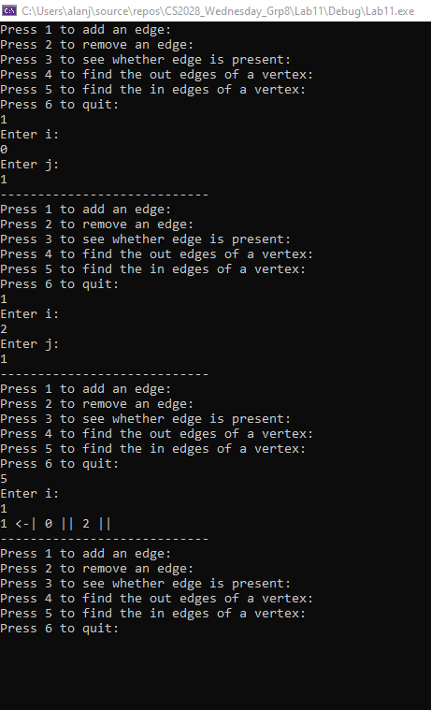

Task 3:

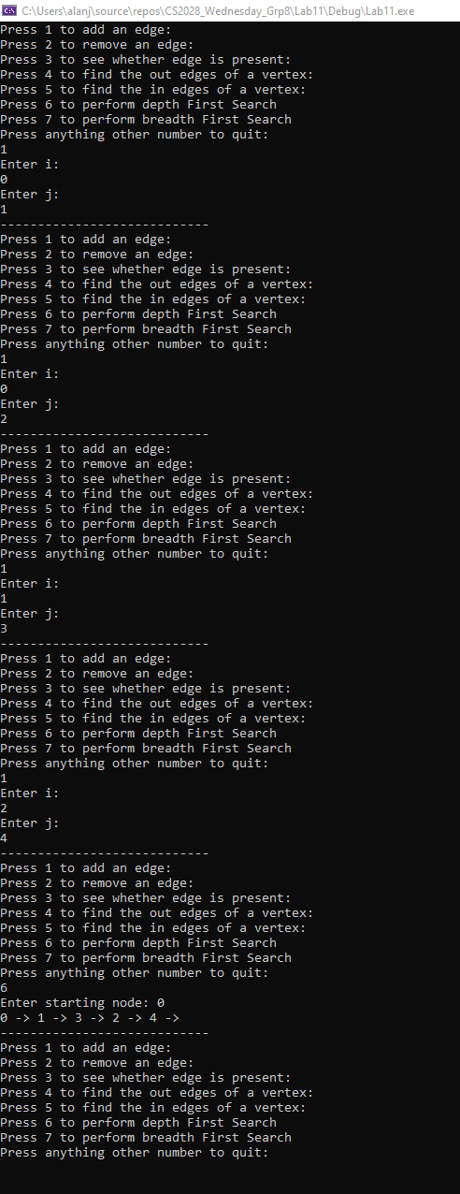

Task 4:

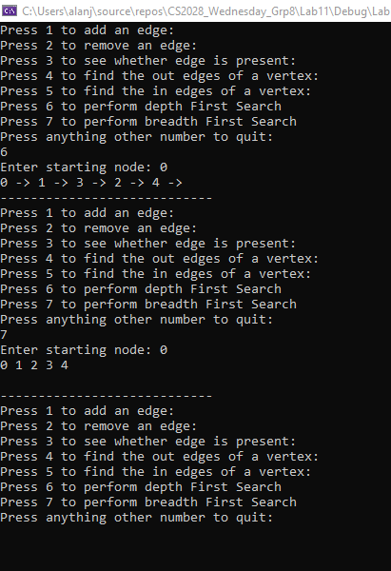

Task 5:

DFS was implemented using recursing and a Boolean array to keep track of whether a node was already visited or not. BFS was also implemented similarly, though recursion was not used. The Graph stores data in the form of an array of ordered-linked-lists. Ordered Linked List was chosen because that would keep the vertices sorted and would aesthetically look better when printed. Also, for the requirements of this lab, O(1) data access was not required, and we were also not supposed to use vectors, hence we went with ordered Linked Lists.

If the tree is wide, BFS would consume more memory as more nodes would be stored in the queue at a time and DFS would use more memory if the tree is deep. Also, DFS would be extremely inefficient when trying to find the shortest possible route to a node.

BFS should be chosen if we know that the tree is deep, whereas DFS should be chosen when the tree is known to be wide if memory consumption is an issue. BFS is usually used to find the shortest possible route in a graph, and various path finding algorithms such as Dijkstra's algorithm, A\*, etc use a variation of BFS.

Contribution:

Everyone worked equally